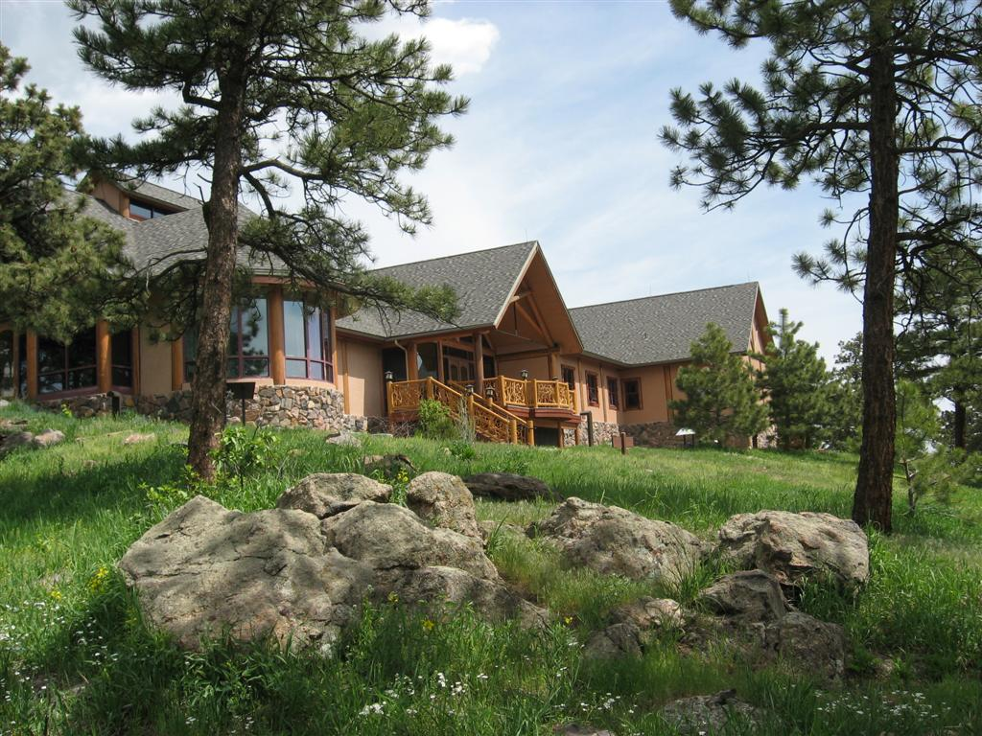  ANCA Regional Meeting  Lookout Mountain Nature Center Friday, April 13, 8:30 a.m. to 4:00 p.m.  Join fellow nature and environmental center directors and senior level staff for informational sessions and networking  Friday sessions on programming, budgeting, volunteers, special events, and board/staff will be facilitated by your summit hosts- Karl Brummert, Audubon Society of Greater Denver; Jill Dreeves, Wild Bear Nature Center; Jeff Lamontagne, Dinosaur Ridge; David Mallery, Bluff Lake Nature Center and Tim Sandsmark, Lookout Mountain Nature Center. A light breakfast, refreshments, and lunch with vegetarian and gluten free options will be provided. | Come learn and mingle with your colleagues in the Colorado Rockies  ____  We welcome and encourage participation from states beyond Colorado too  ____  An optional opening reception and guided walk will be held Thursday, April 12 at 4:30 p.m. at the world-renowned Dinosaur Ridge with snacks and refreshments  ____  Fee: $20/person for lunch, refreshments, light breakfast Payable by Cash or check upon arrival  ____  RSVP to Tim Sandsmark  tsandsma@jeffco.us 720-497-7653  Lookout Mountain Nature Center  910 Colorow Road  Golden, CO 80401  720-497-7600  RSVP by April 10 to: Tim Sandsmark tsandma@jeffco.us 720-497-7653

