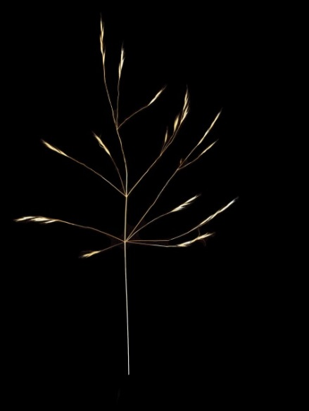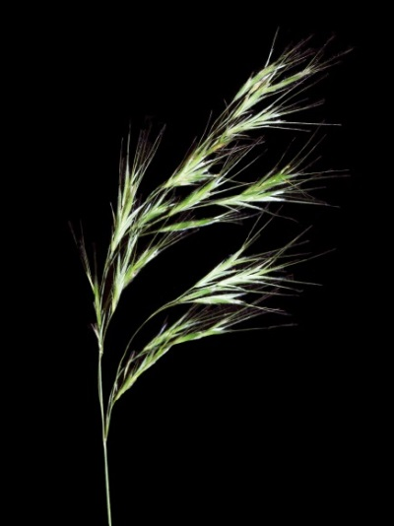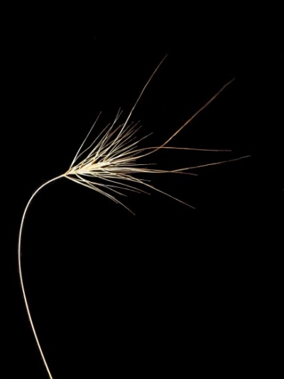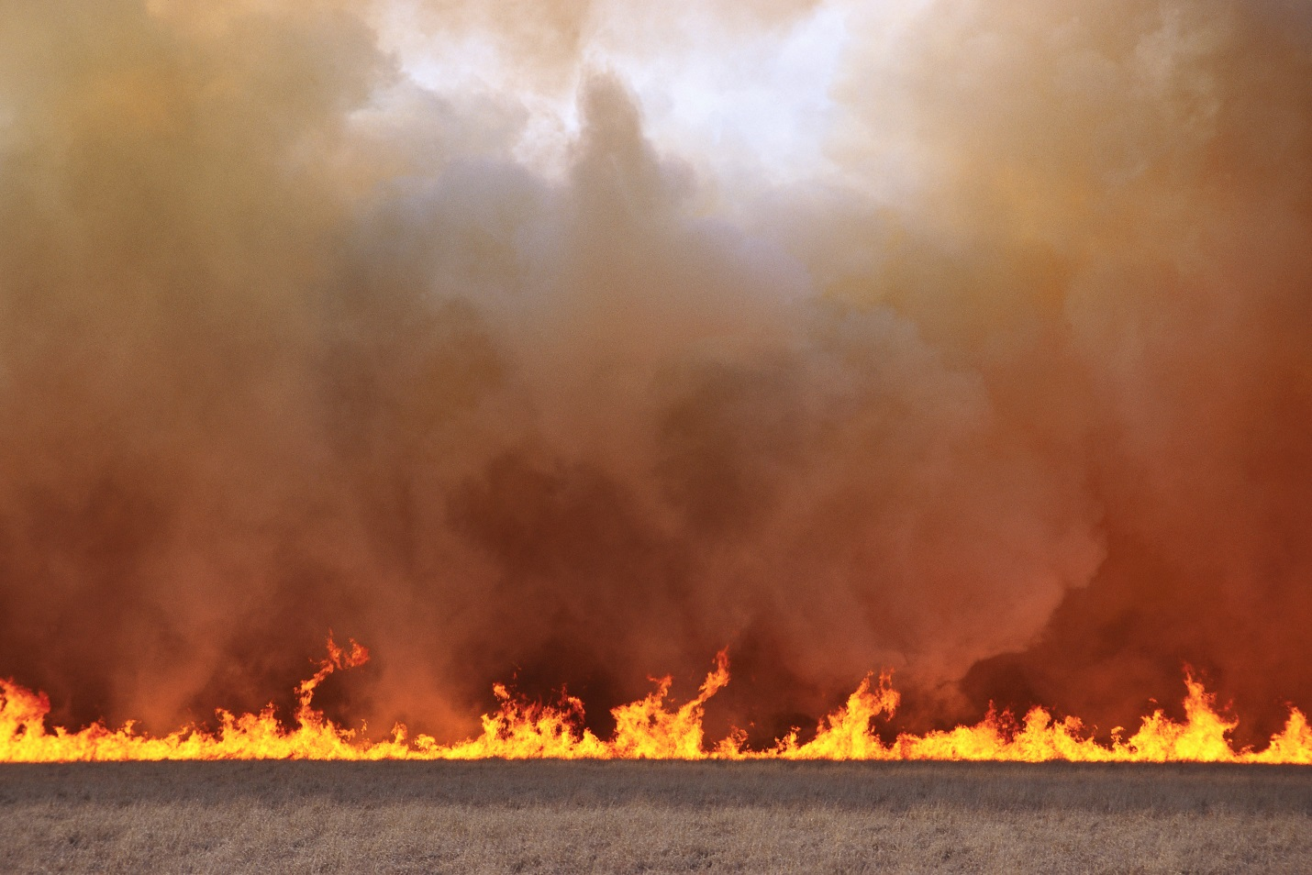

**Webinar Symposium, Wednesday May 30, 2018 (8:00 AM to 12:30 PM)**

**Field Tour Thursday May 31, 2018 (8:00 AM – 3:00 PM)**

**Targeting the Triple Threat**

**Cheatgrass**

**Medusahead**

**Ventenata**

(Photos: B. Fowers, UW)

**Location: Event Hall, Morgan Library, Colorado State University**

**OR Online.**

**Register Online** [**HERE**](https://extension.zoom.us/j/396848763)

**Register for In-Person Attendance and Field Trip** [**HERE**](https://www.eventbrite.com/e/targeting-the-triple-threat-invasive-winter-annual-grasses-symposium-tickets-45451567863)

**Symposium Overview: Invasive annual grasses such as cheatgrass *(Bromus tectorum)*, medusahead *(Taeniatherum caput-medusae)*, and ventenata (*Ventenata dubia)* are devastating western natural areas and rangeland at a landscape scale. This cycle favors further invasions while eliminating desirable vegetation and wildlife habitat. Further impacts include:**

* **A continuous bed of fine fuel associated with an increase in frequency and intensity of rangeland wildfire**
* **Significant reduction or elimination of desirable perennial species**
* **Reduced forage quality for wildlife and livestock**
* **Increased risks for wildlife and pollinator species**
* **Resulting wildfires that are a threat to humans, wildlife, property and infrastructure.**

**Speakers will address all of these points including a university/industry research update on current management tools for the “triple threat”.**

**Symposium Agenda:**

**Moderator:** Gloria Edwards (Southern Rockies Fire Science Network)

**8:00 – 8:05:** **Gloria Edwards** - *Introduction*

**8:05 – 8:35**: **Matt Germino, USGS -** *Setting the Stage*: *landscape scale transformations and current available management tools*

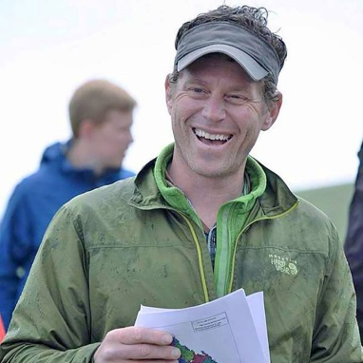 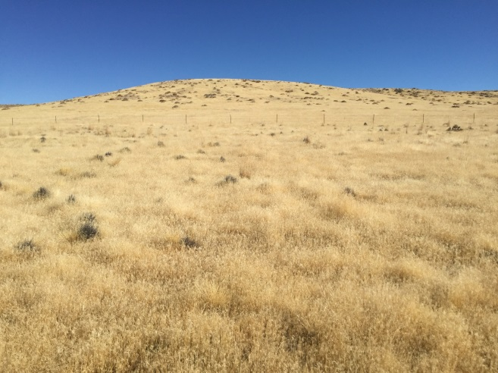 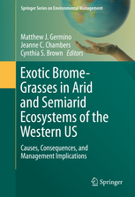

**8:35-9:05:** **Matthew Brooks, USGS -** *How exotic annual grasses alter wildfire regimes across varying ecosystems in the west?*

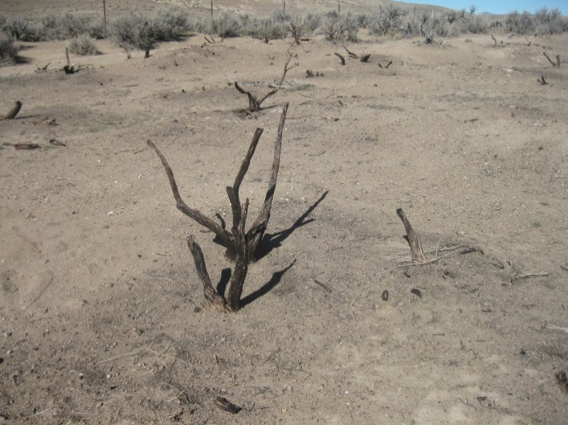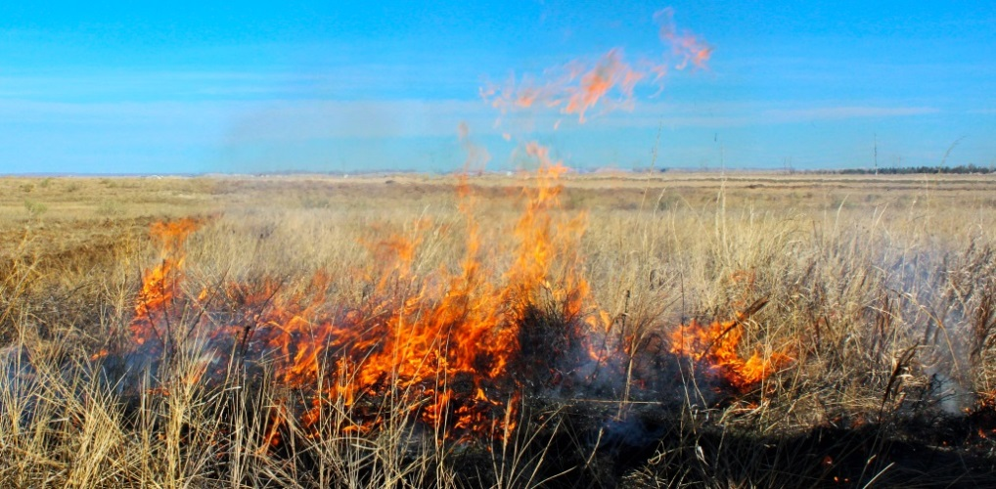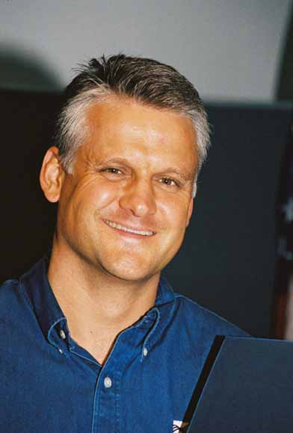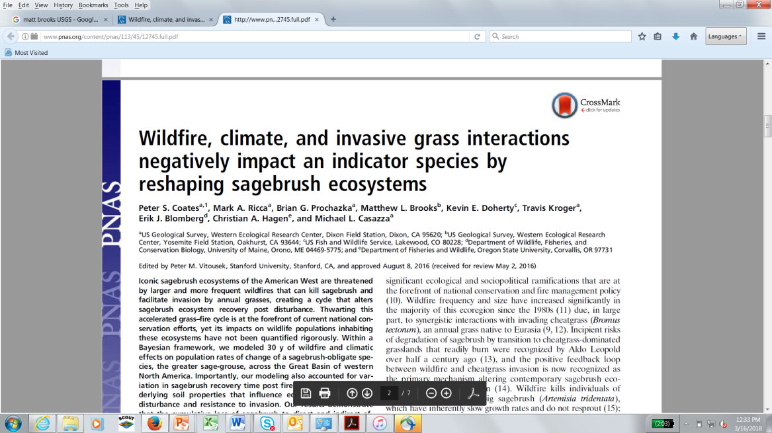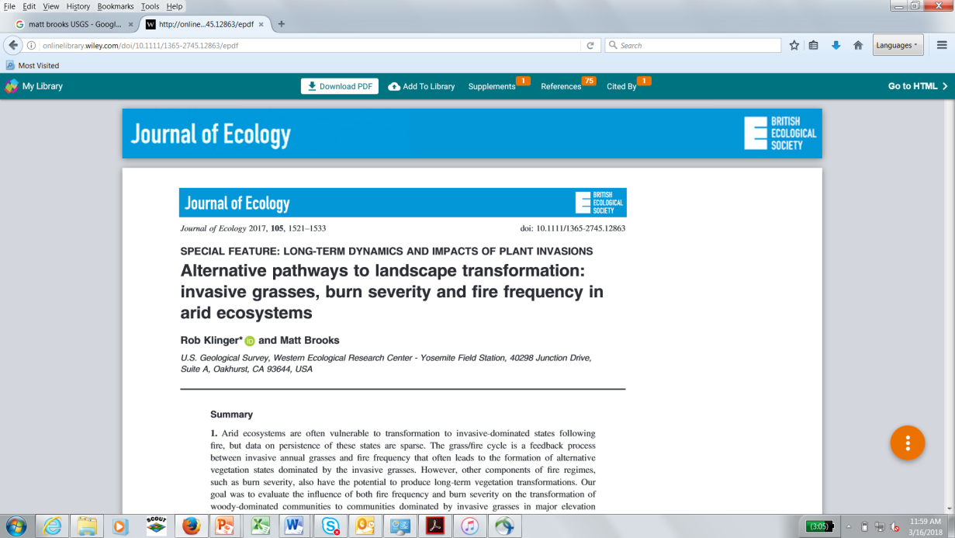

**9:05- 9:35: Roy Averill-Murray USFWS** - *Iconic At-Risk Species in the Mojave Desert Endangered by the Spread of Invasive Annual Grasses.*

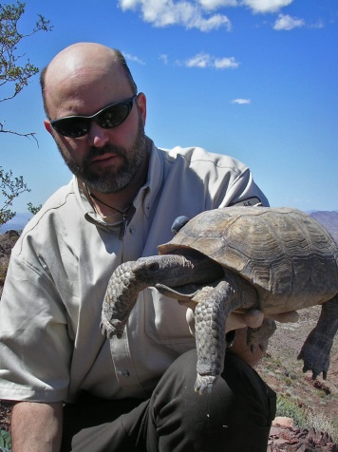 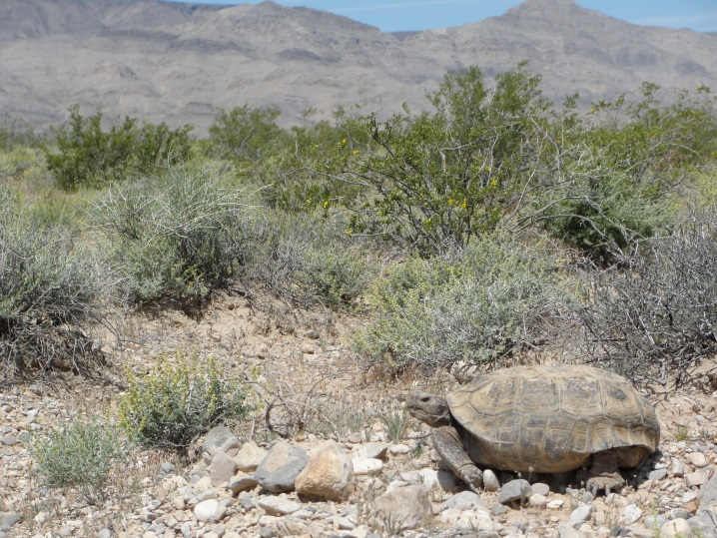

**9:35 – 10:05: Lindy Garner USFWS- R6 Invasive Species Branch Lead *–*** *Wildlife species impacted by invasive annual grass fueled fires in the west (sage-grouse and beyond).*

**Green-tailed towhee  
Photo Jacob Spendelow**

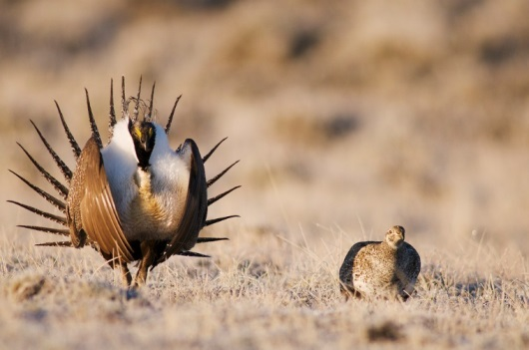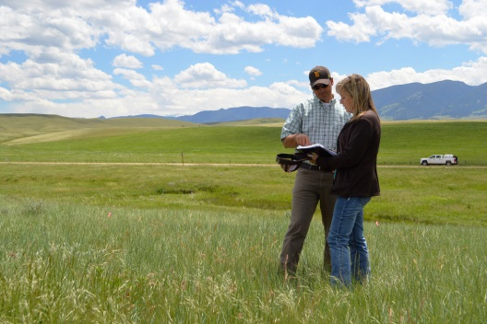

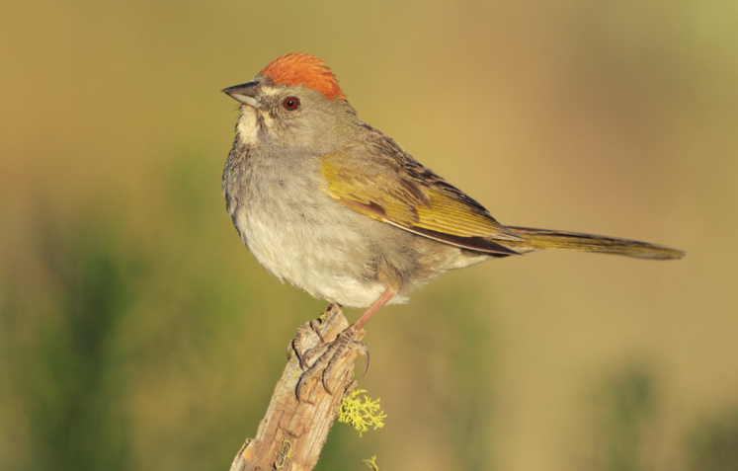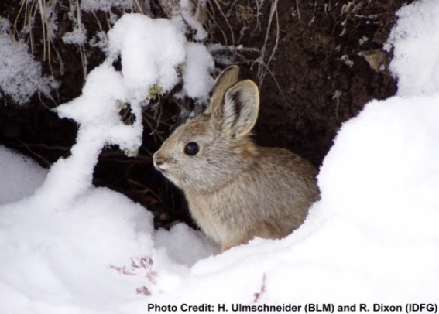

**Pygmy Rabbit**

**Green-tailed towhee  
Photo Jacob Spendelow**

**10:05-10:15 - 1st Question & Answer session**

**10:15-10:30 - Break**

**10:30 – 11:00: Dr. Derek Sebastian (Bayer VM Stewardship and Development Team) and Shannon Clark (CSU PhD Candidate)**: *Seed bank depletion: the key to long term invasive winter annual grass control. Introduction to a new herbicide tool for long-term control.*

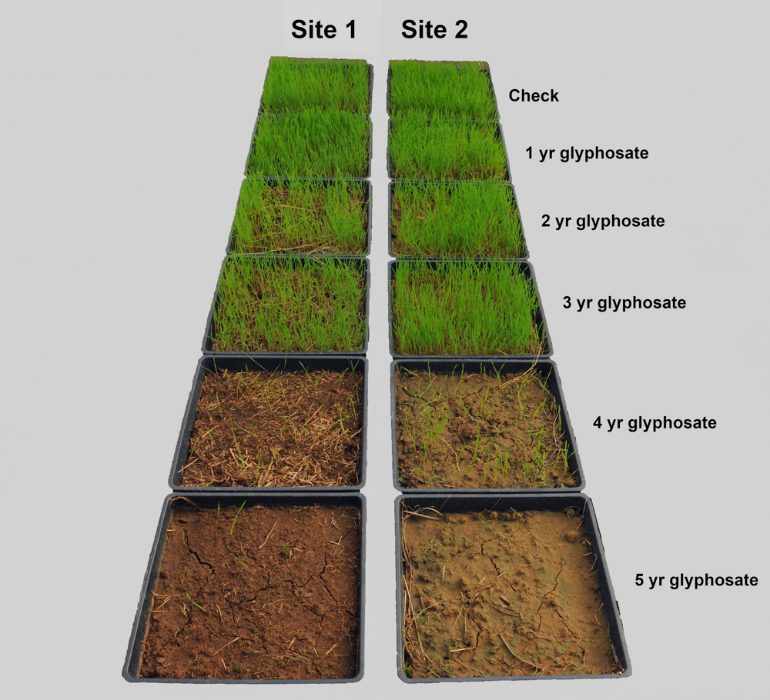 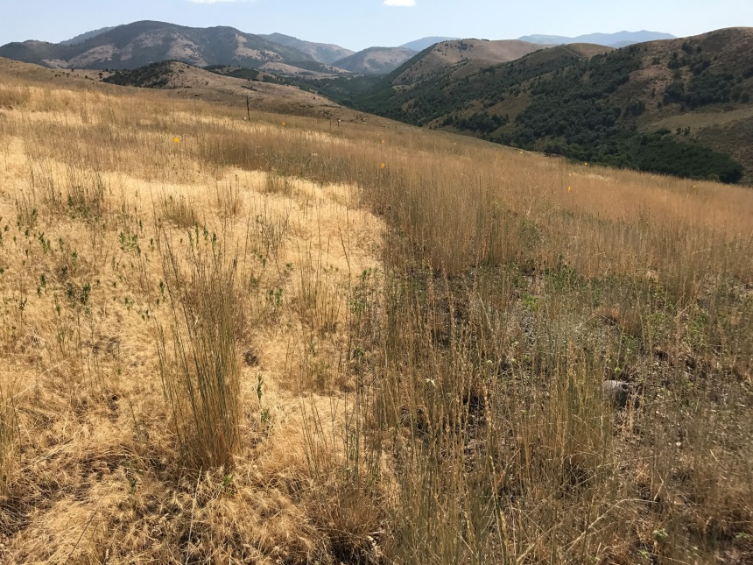

**Treated: Ecosystem Restoration**

**Non-treated**

**11:00- 12:00: University Research Updates on the Triple Threat   
(15 min each):**  
*Dr. Scott Nissen (Colorado State University, Cheatgrass Control)  
Dr. Ian Burke (Washington State University, Ventenata Control)   
Dr. Corey Ransom (Utah State University, Medusahead/Cheatgrass Control)  
Tom Getts (UC Davis, Medusahead Control)*

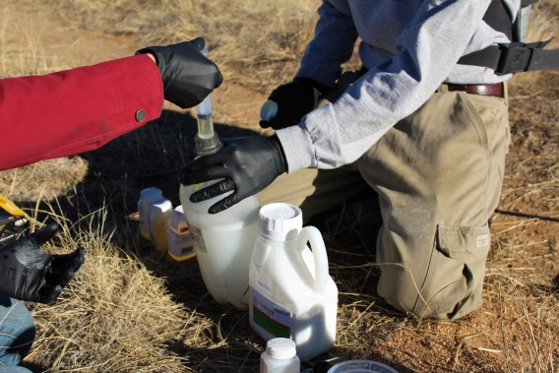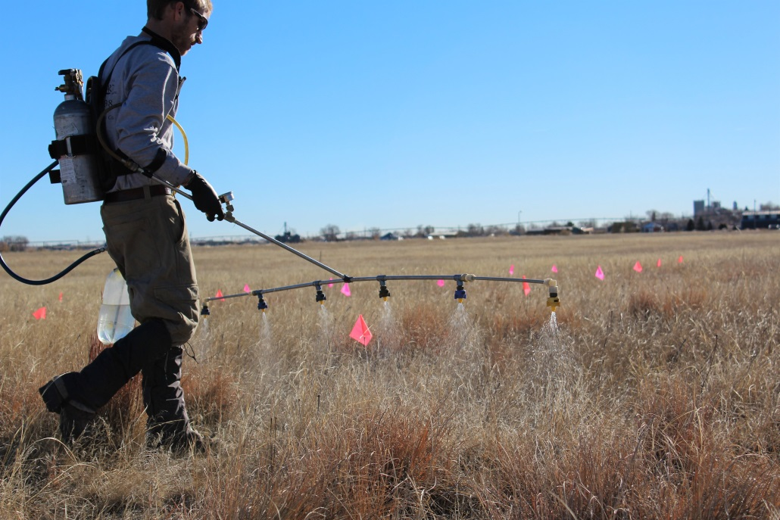

**Universities:**



**12:00 – 12:10: Dr. Harry Quicke (Bayer VM Stewardship and Development Team)** *Wrap-up and Summary.*

**12:10 – 12:30: 2nd Question & Answer session**

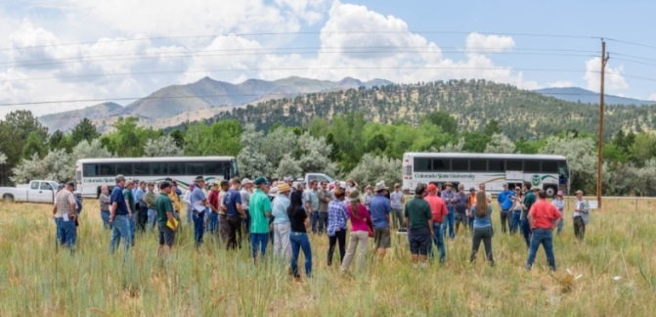

**Field Tour: Thursday May 31, 2018 (8:00 AM to 3:00 PM)** *Visit research trials and operational scale treatments along the Colorado Front Range demonstrating a new tool for long-term cheatgrass control and ecosystem restoration. Lunch provided! Click* [***HERE***](https://www.eventbrite.com/e/targeting-the-triple-threat-invasive-winter-annual-grasses-symposium-tickets-45451567863)*for more information.*

**“Targeting the Triple Threat” Supporting Groups**:

