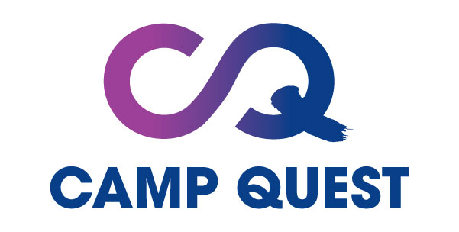

Camp Quest provides a fun, memorable summer experience for campers to celebrate their diversity, discover the natural world around them, and forge lasting friendships in a supportive, like-minded community. Our Camp Quest campers come as unique individuals, learn and share in educational and inquisitive adventures, and leave as enriched individuals, confident in making an impact and passing on their humanist values in their own home communities.

OUR MISSION
Camp Quest provides an educational adventure shaped by fun, friends and freethought, featuring science, natural wonder and humanist values.

OUR VISION
Camp Quest envisions a world in which children grow up exploring, thinking for themselves, connecting with their communities, and acting to make the most of life for themselves and others.

OUR GOALS
Through our programs, we seek to:
- Develop inclusive communities that celebrate diversity.
- Foster inquisitive thinking and exploration of the natural world
- Cultivate empathy and relationship building as foundations of an ethical, productive, and fulfilling life
- Provide a safe and fun environment for personal and social growth

VOLUNTEERS
Camp Quest relies on volunteers from across the country to run our camps and programs. Below are two key volunteer positions available.

Camp Counselors & Cabin Leaders
Camp counselors serve as cabin leaders and are primarily in charge of a small group of campers. Counselors help campers experience Camp Quest at its best by providing social and learning support, assisting with programs, and participating in camp events.

Camp Program Leaders
Program leaders typically run educational activities at camp, from science experiments, crafts and philosophy discussion groups to leading hikes! Program leaders sometimes also serve as counselors & Cabin Leaders.

Please visit our website for more information and to apply: https://campquest.org/

