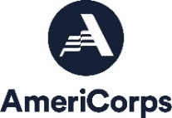
Rainbow Affinity Crew
Fall Forestry Corpsmember
(Colorado Springs)

Position Description:
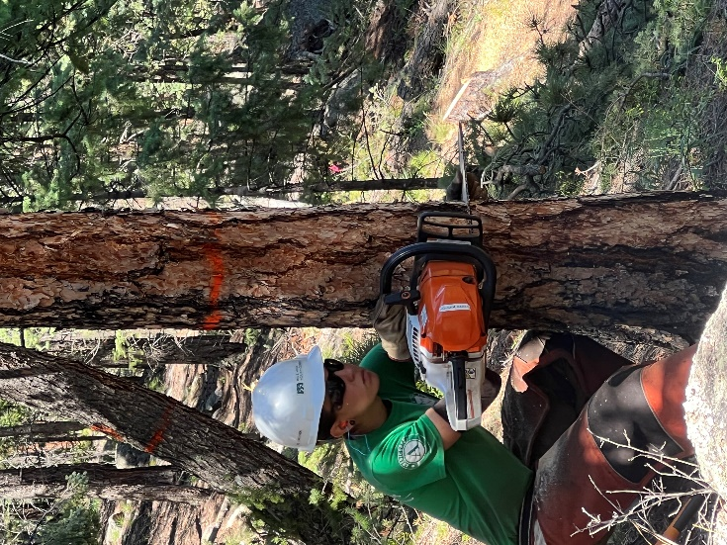
The Rainbow Affinity Crew is for LGBTQIA+ identifying participants (called Corpsmembers) to explore the natural resource management field, gain experience, and acquire technical skills in a safe and supportive environment. LGBTQIA+ stands for lesbian, gay, bisexual, transgender, queer or questioning, intersex, asexual, and more.

Inclusivity is a core value at MHYC, and the Rainbow Crew embodies this value by helping to create a safe community for people of all types of sexuality and gender identities. Aligning with the strategic priorities of the major federal land management agencies, our goal is to promote a more inclusive public lands workforce informed by diverse perspectives and voices. This crew will be led and supported by Crew Leaders and staff that identify as part of the LGBTQIA+ community and be provided with educational opportunities aimed at further understanding and exploring historically marginalized identities.

The Rainbow Affinity Crew is part of a team-based, 10 week-long Fall Forestry Program. The crew will complete sawyer project on public lands throughout the Southern Front Range region. Corpsmembers on a sawyer crew operate chainsaws on invasive tree removal and wildland fire mitigation projects. They receive First-Aid/CPR and S-212 Wildland Fire Chainsaws certifications. Some sawyers will have the opportunity to receive pesticide application training. The use of pesticide is common on invasive tree removal projects.

Corpsmembers will be enrolled in AmeriCorps—a national community service program. No experience is required! We will provide you with hands-on training related to all projects.

Compensation and Benefits:
- Biweekly Stipend - Earn a living stipend of $1,120 before taxes paid every 2 weeks.
  - Leadership Opportunities available: Corpsmember Drivers are eligible for a living stipend of $1,140. Returning Corpsmembers earn $1,160. More information available on request.
  - AmeriCorps Education Award - Earn a scholarship of $1,374.60 upon successful completion of the term (300 hours of service). This award can be used to pay future tuition, pay back qualifying student loans or go on an expedition through a wilderness school! Corpsmembers have 7 years to use the award.
  - Student Loan Forbearance - Corpsmembers can apply to put their qualified federal student loans on hold during their term through the National Service Trust.
- Health Insurance - Corpsmembers are eligible for health insurance the 1st of the month after serving at MHYC for 60 days. Corpsmember contribution required.
- Counseling - Corpsmembers receive up to 4 free mental health counseling sessions per year.
- Networking - Corpsmembers have daily opportunities to network with federal, state and local natural resources professionals and access to a vast alumni network!
- Training – Depending on crew assignments, Corpsmembers will receive training in one or more stewardship skillsets, including S-212 Wildland Fire Chainsaws (required for sawyers), trail building and maintenance, and pesticide application.

Timeline:
This is a temporary position from August 21-October 27, 2023
- 300 hours of service in a 10 week commitment.
- 40 hour weeks, schedules TBD, this position requires overnight camping.
MHYC is committed to hiring candidates with unique backgrounds and perspectives. If you are interested in this position but are concerned that you do not meet all of the requirements or possess all of the necessary skills, or that prior convictions or your background might disqualify you, we highly encourage you to submit an application anyway.

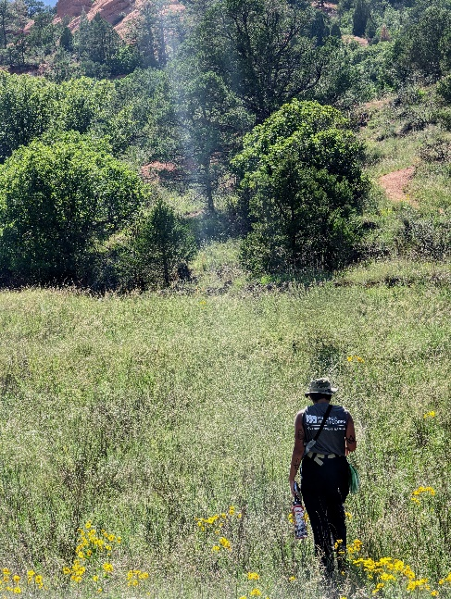
Qualifications:
- Between the ages of 18-24.
- High school or GED/HSE graduate or still enrolled.
- Must be eligible for enrollment in AmeriCorps as a US Citizen, National or Lawful Permanent Resident. Documentation will be required on the first day. Must bring identification documents necessary to complete the I-9 and other forms on your first day.
- Must be physically fit, able to lift 50 lbs., spend 8-10 hours a day in all weather conditions (e.g., sun, heat, wind, rain, etc.) and hike 7 miles with a day-pack.
- Able to be on time and maintain consistent attendance throughout term of service. Must commit to complete the program.

Requirements:
- Pre-service National Service Criminal History Check required; this position does not have recurring access to vulnerable populations.
- Corpsmembers must not engage in any prohibited activities as listed in the AmeriCorps Member Service Agreement.
- This position reports to Program Coordinator: Land Conservation.
- Service location: 417 E. Vermijo Avenue, Colorado Springs, CO 80903.

To Apply:
Visit our website at www.milehighyouthcorps.org and click “Apply Now”.
Questions? Email lalitam@mhyc.net or call 719-822-6047.
Mile High Youth Corps is committed to diversity in principle and practice, both in the community at large and within the organization. We are, therefore, committed to having our internal operations and employment practices administered on a non-discriminating basis inclusive of, but not limited to, race, religion, color, socio-economic status, gender, age, sexual orientation, military or veteran status, physical or mental disability, marital status, or national origin. Every effort shall be made to grant reasonable accommodation for qualified people with disabilities to participate in this AmeriCorps program.

