Work outdoors, make a difference, and make a better future for yourself at Mile High Youth Corps.

We are a group of young people who are focused on benefitting the environment and educating ourselves on the issues that face our community.

This is not like other jobs. We are a grassroots organization that is committed to providing training, mentorship, and opportunities to youth.

Spend 2024 being supported by supervisors who care about your development, peers that are passionate about nature, and a real community. Who knows where this could lead you?

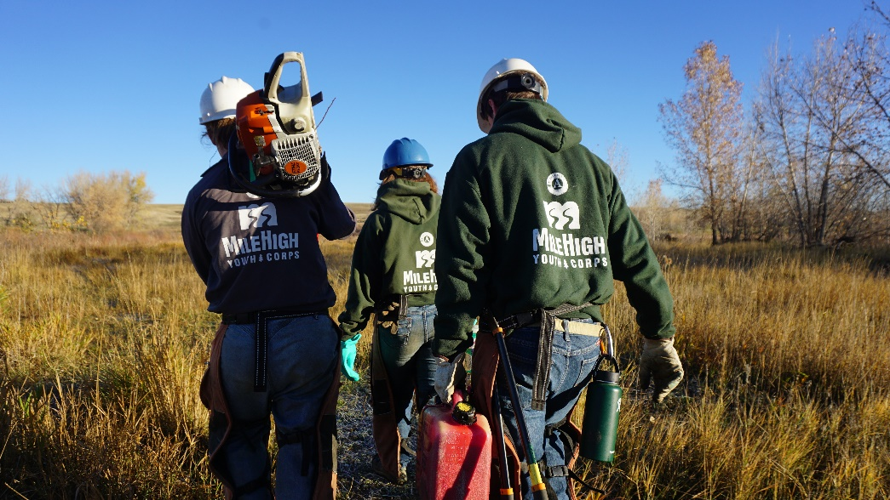

Become a Land Conservation Leader for our Land Conservation program based in Denver! The Land Conservation program is a team-based, 13 week-long program for individuals between the ages 18-24. Land Conservation Leaders guide and support Trail or Forestry participants (called Corpsmembers) as they serve on environmental stewardship projects on public lands throughout the Denver metro area. Crew Leaders will be enrolled in AmeriCorps—a national community service program.
Land Conservation Leaders will earn up to $1,320.00 biweekly and earn a $4,826.50 scholarship at the same time! The total compensation including biweekly pay and AmeriCorps Education Award is $23,760.

Never had a job outside? Not sure if you like this kind of work? That's okay! Our goal is to support you with the knowledge and team that you need to be successful. We will provide you with hands-on training related to all projects.
All we ask is that you bring your dedication to hard work, a positive attitude, and a commitment to an experience you’ll never forget.

Apply on our website at https://www.milehighyouthcorps.org/apply-now
Quesstions? Email matthewl@mhyc.net or call 303-433-1206 ext. 262.

MHYC is committed to hiring candidates with unique backgrounds and perspectives. If you are interested in this position but are concerned that you do not meet all of the requirements or possess all of the necessary skills, or that prior convictions or your background might disqualify you, we highly encourage you to submit an application anyway.

