Land Conservation Crew Member
(Colorado Springs)

Position Description:
Land Conservation Crew Members (called Corpsmembers) serve on environmental stewardship projects throughout the Southern Front Range region. Corpsmembers will be enrolled in AmeriCorps—a national community service program. No experience is required! We will provide you with hands-on training related to all projects.
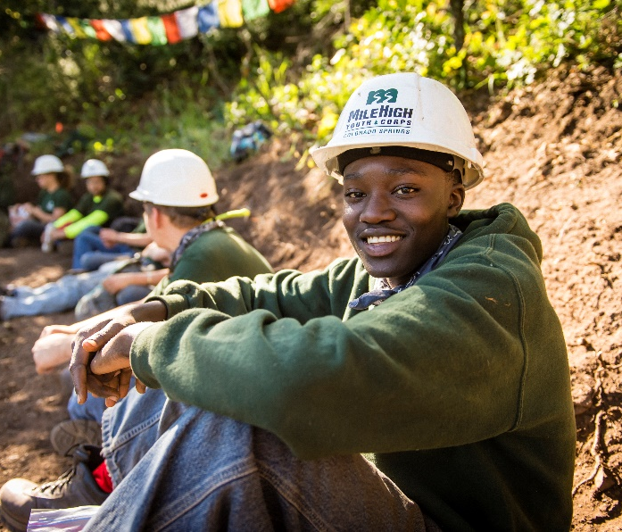
Compensation and Benefits:
- Biweekly Stipend - Earn a living stipend of $1,120 before taxes paid every 2 weeks.
  - Leadership Opportunities available: Corpsmember Drivers are eligible for a living stipend of $1,140. Returning Corpsmembers earn $1,160. More information available on request.
  - AmeriCorps Education Award - Earn a scholarship upon successful completion of service. This award can be used to pay future tuition, pay back qualifying student loans or go on an expedition through a wilderness school! Corpsmembers have 7 years to use the award.
  - Student Loan Forbearance - Corpsmembers can apply to put their qualified federal student loans on hold during their term through the National Service Trust.
- Counseling - Corpsmembers receive up to 5 free mental health counseling sessions per year plus additional services through a Member Assistance Program.
- Networking - Corpsmembers have opportunities to network with federal, state and local natural resources professionals and access to a vast alumni network!
- Training – Depending on crew assignments, Corpsmembers will receive training in one or more stewardship skillsets, including S-212 Wildland Fire Chainsaws (required for sawyers), trail building and maintenance, and pesticide application.

Corpsmembers have the choice to serve on a variety of crews. MHYC staff will work with you to find the best match! We strive for each and every crew to be diverse, inclusive and safe for all Corpsmembers.

Crew Type | Start Date | End Date | Schedule* (80 hours over 2 weeks in a combination of the following schedules) | Service Term | AmeriCorps Education Award
Summer of Service
Camping Chainsaw Crew | May 20 | Aug. 16 | Monday – Thursday 8:00 a.m. – 5:30 p.m. Every other Friday 8:00 a.m. – 4:30 p.m. | 450 hours, 13 weeks | $1,824.07
Day Trail Crew | May 20 | Aug. 16 | Monday – Thursday 8:00 a.m. – 5:30 p.m.  Every other Friday 8:00 a.m. – 4:30 p.m. | 450 hours, 13 weeks | $1,824.07
Camping Trail Crew | May 20 | Aug. 16 | Monday – Thursday 8:00 a.m. – 5:30 p.m.  Every other Friday 8:00 a.m. – 4:30 p.m. | 450 hours, 13 weeks | $1,824.07
Day Trail and Backpacking Trail Crew | May 20 | Aug. 16 | Schedule varies over the term:  Monday – Thursday 8:00 a.m. – 5:30 p.m.  - For 5 weeks of the 13-week season  Wednesday – Wednesday 8:00 a.m. - 5:30 p.m.  - For 8 weeks  Every other Friday 8:00 a.m. – 4:30 p.m. | 450 hours, 13 weeks | $1,824.07
Summer of Service and Fall Forestry
Day Chainsaw Crew | May 20 | Nov. 15 | Monday – Thursday 8:00 a.m. - 5:30 p.m.  Every other Friday 8:00 a.m. – 4:30 p.m. | 900 hours, 26 weeks | $3,447.50
Crew assignment varies | May 20 | Nov. 15 | To be determined based on crew type | 900 hours, 26 weeks | $3,447.50
Fall Forestry
Camping Hand Crew | Sept. 3 | Nov. 8 | Monday – Thursday 8:00 a.m. - 5:30 p.m.  Every other Friday 8:00 a.m. – 4:30 p.m. | 300 hours, 10 weeks | $1,459.26
Day Noxious Weed Management Crew | Sept. 3 | Nov. 8 | Monday – Thursday 8:00 a.m. – 5:30 p.m.  Every other Friday 8:00 a.m. – 4:30 p.m. | 300 hours, 10 weeks | $1,459.26
Backpacking and Camping Chainsaw Crew | Sept. 3 | Nov. 8 | Wednesday – Wednesday 8:00 a.m. - 5:30 p.m.  Every other Friday 8:00 a.m. – 4:30 p.m. | 300 hours, 10 weeks | $1,459.26
*Variance in schedules may occur due to observed holidays

Crew Type Descriptions:
- Chainsaw - primarily complete invasive tree removal and wildland fire mitigation projects.
- Trail/Hand - primarily complete trail maintenance and construction, fence construction and demolition, ecological restoration, and other park development projects.
- Noxious Weed Management - trained on how to safely handle and apply pesticides for invasive species removal projects, the role of pesticides in natural resources management, native and invasive species identification and how to operate a variety of hand pump and backpack sprayers.
- Day - complete projects in nearby locations, starting and ending each day at the MHYC warehouse. Day crews are ideal for projects close to urban areas or easily accessible sites.
- Camping - complete projects further away from the MHYC warehouse, setting up camp near the project site and your vehicles to minimize travel time.
- Backpacking - complete projects that are in remote areas that are difficult to access with vehicles. These projects require members to complete a strenuous hike in to establish a base camp. Due to the remote nature of these sites, backpacking crews complete longer-duration projects for 8 consecutive days.
MHYC is committed to hiring candidates with unique backgrounds and perspectives. If you are interested in this position but are concerned that you do not meet all of the requirements or possess all of the necessary skills, or that prior convictions or your background might disqualify you, we highly encourage you to submit an application anyway.

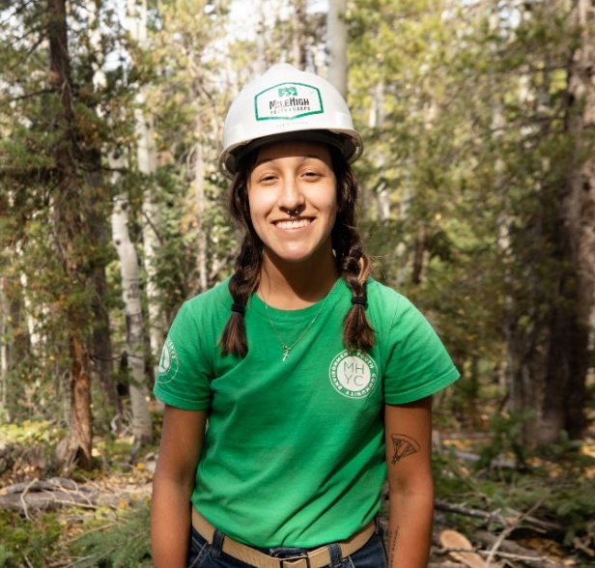
Qualifications:
- Between the ages of 18-24.
- High school or GED/HSE graduate or still enrolled.
- Must be eligible for enrollment in AmeriCorps as a US Citizen, National or Lawful Permanent Resident. Documentation will be required on the first day. Must bring identification documents necessary to complete the I-9 and other forms on your first day.
- Must be physically fit, able to lift 50 lbs., spend 8-10 hours a day in all weather conditions (e.g., sun, heat, wind, rain, etc.) and hike up to 7 miles with a day-pack.
- Able to be on time and maintain consistent attendance throughout term of service. Must commit to complete the program.

Requirements:
- Pre-service National Service Criminal History Check required.
- Corpsmembers must not engage in any prohibited activities as listed in the AmeriCorps Member Service Agreement.
- This position reports to Program Coordinator: Land Conservation.
- Service location: 417 E. Vermijo Avenue, Colorado Springs, CO 80903.
To Apply:
Visit our website at www.milehighyouthcorps.org and click “Apply Now”.
Questions? Email lalitam@mhyc.net or call 719-630-7421 ext. 404
Mile High Youth Corps is committed to diversity in principle and practice, both in the community at large and within the organization. We are, therefore, committed to having our internal operations and employment practices administered on a non-discriminating basis inclusive of, but not limited to, race, religion, color, socio-economic status, gender, age, sexual orientation, military or veteran status, physical or mental disability, marital status, or national origin. Every effort shall be made to grant reasonable accommodation for qualified people with disabilities to participate in this AmeriCorps program.

